MySQL Assignment 1 – DDL Commands & Constraints
DDL Commands :
1. Table Creation (CREATE): Create a database named
“employee” 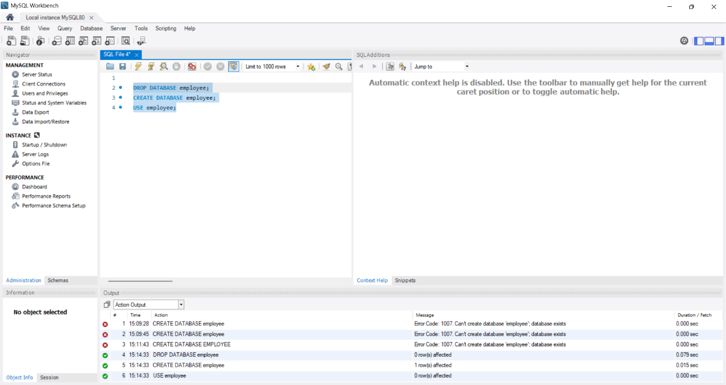
⦿ Departments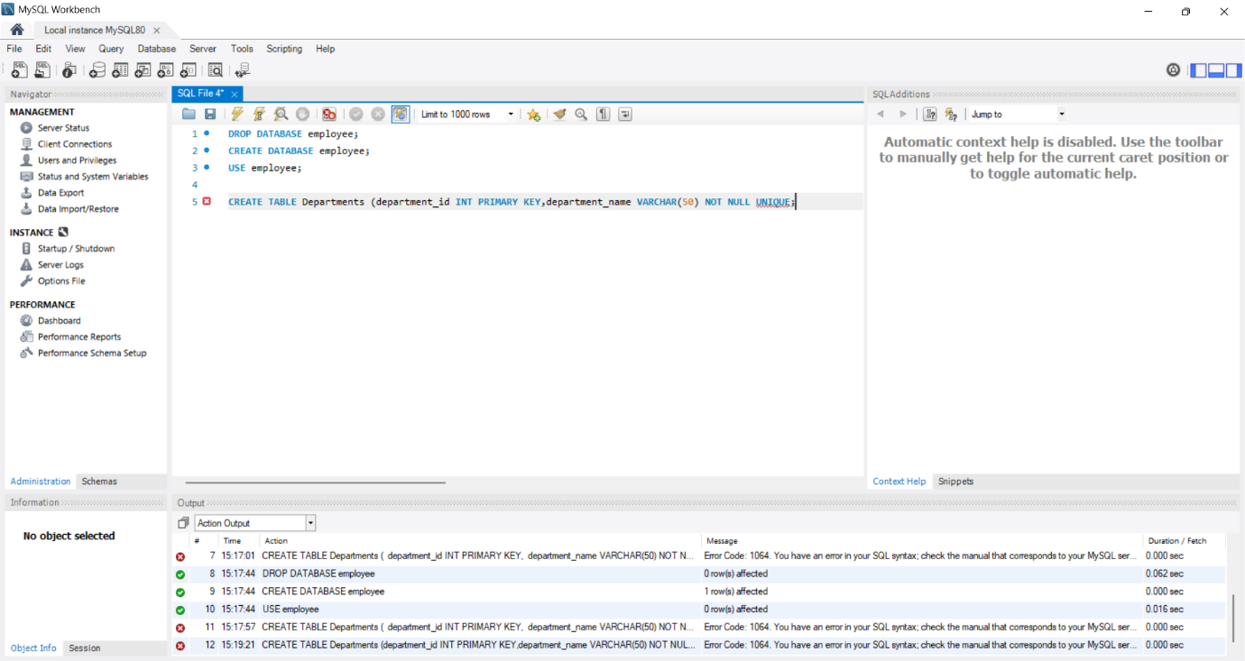
⦿ Location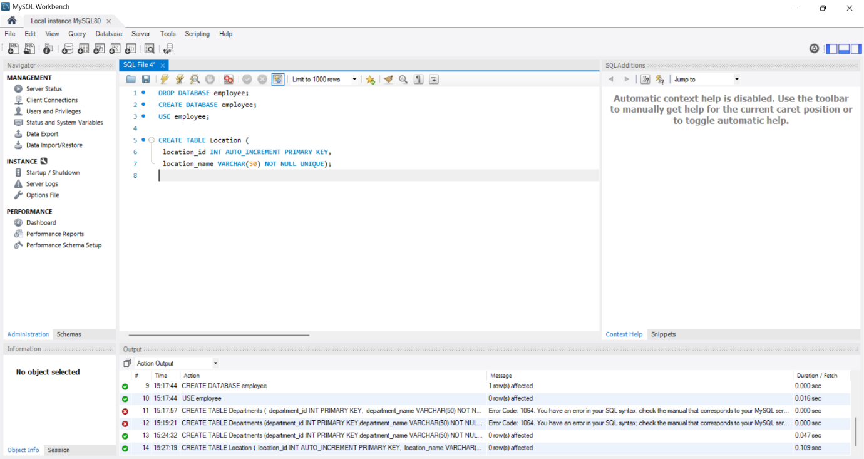
⦿ Employees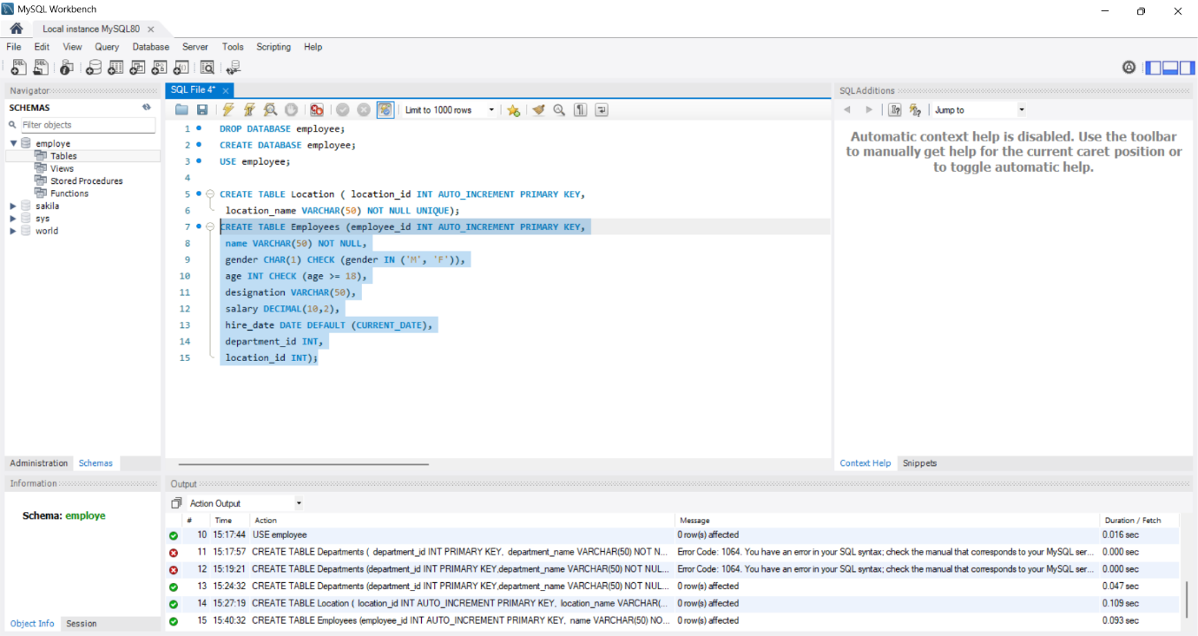
Table Alteration (ALTER):
⦿ Add a new column named "email" to the Employees table to store
employee email addresses. 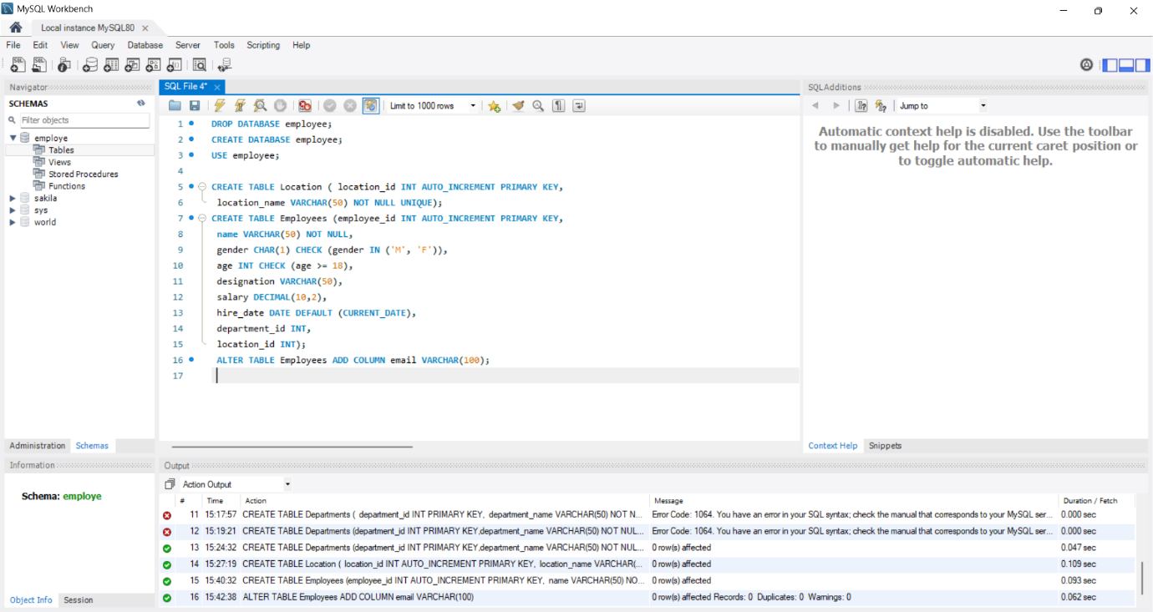
⦿ Modify the data type of the "designation" column in the Employees
table to support a wider range of values. 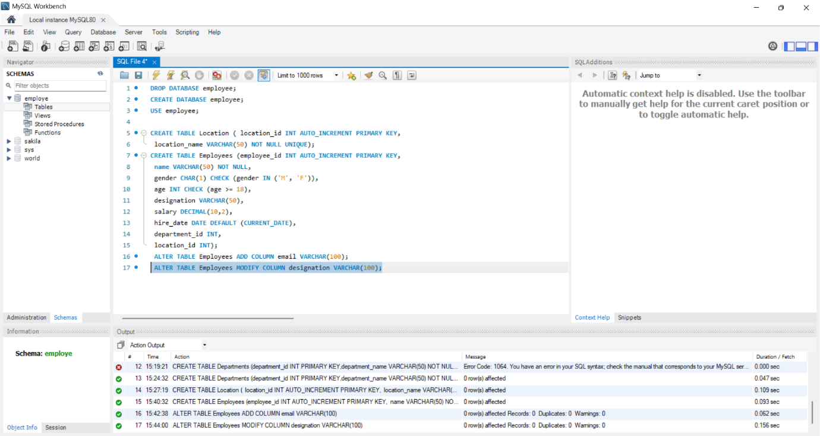
⦿ Drop the “age” column from the Employees table. 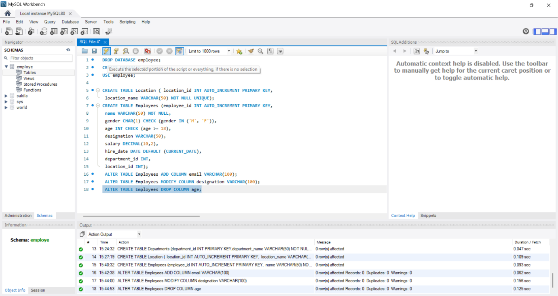
⦿ Rename the “hire_date” column to “date_of_joining”. ⦿ Modify the data type of the "designation" column in the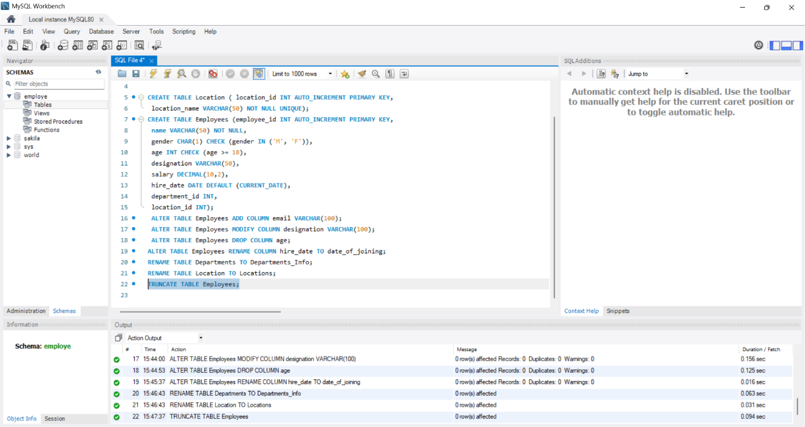
Table Renami

AME):
Employees
table to support a wider range of values.
Table Renaming (RENAME):
⦿ Rename the "Departments" table to "Departments_Info".
⦿ Rename the "Location" table to "Locations".
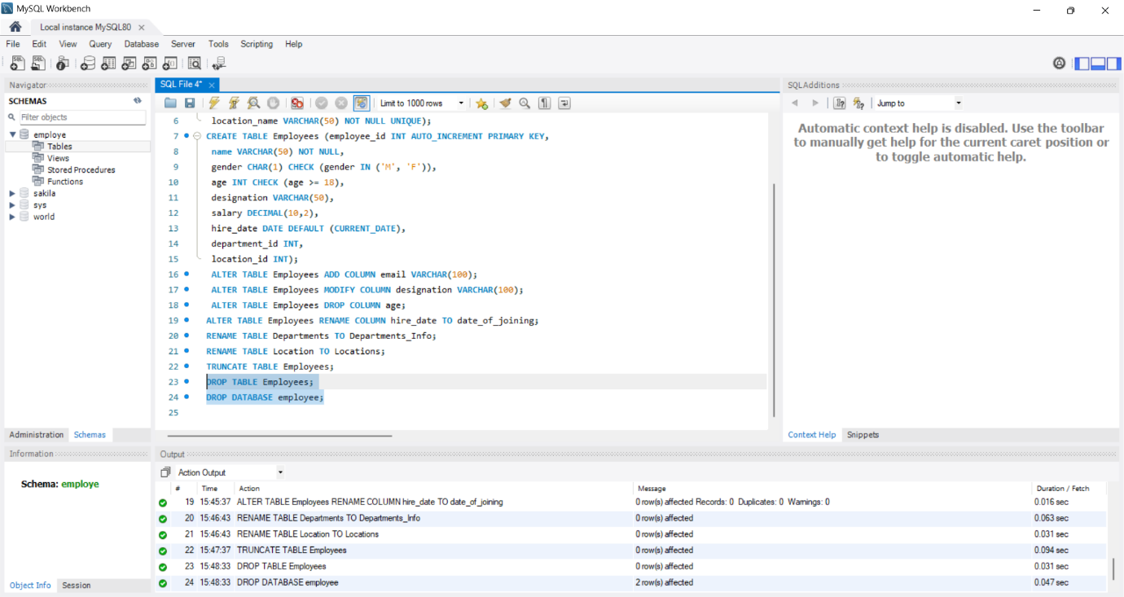
Table Truncation (TRUNCATE)
Database & Table Dropping (DROP): 5. Database & Table Dropping (DROP):

5. Database & Table Dropping (DROP):

Database Recreation:

Departments Table 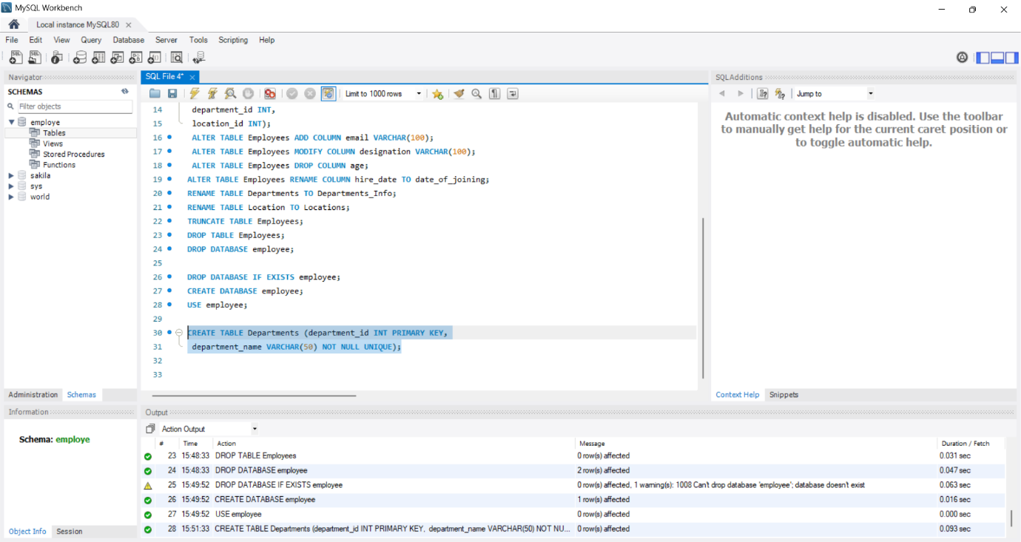
Location Table: 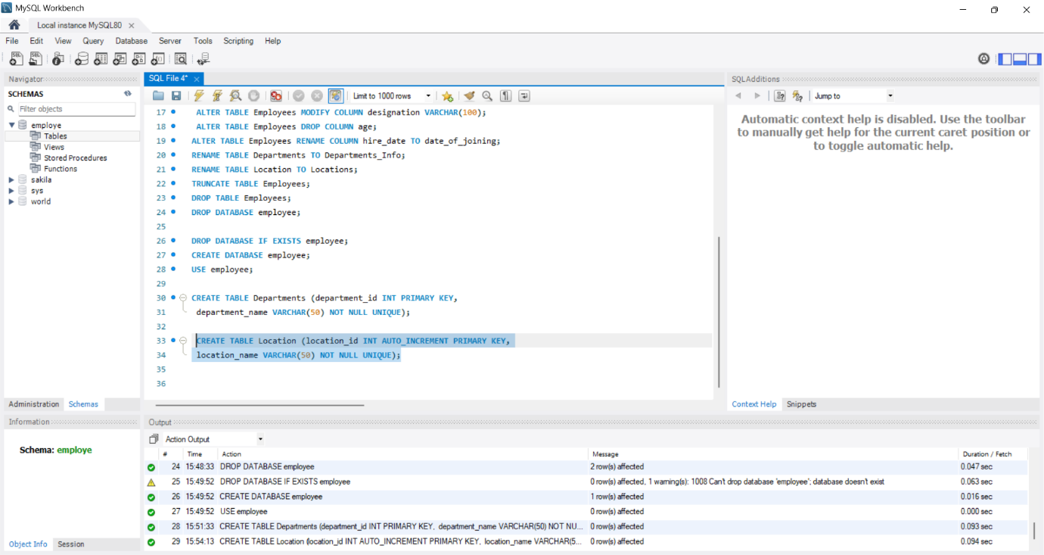
Employees Table 